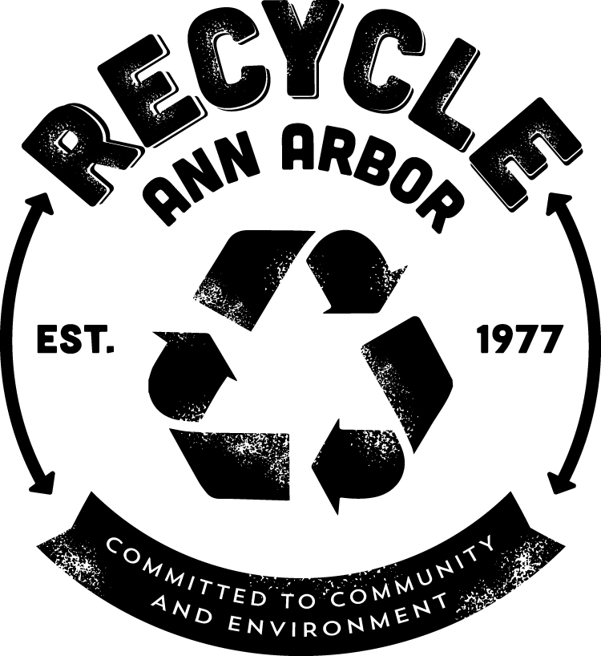

JOB TITLE:
Recovery Yard Administrative Support Specialist Part Time Temporary - Clerical 30 hours per week

LOCATION:
Recycle Ann Arbor Recovery Yard, 7891 Jackson Rd., Ann Arbor MI 48103

FLSA STATUS:
This position is considered a part-time, non-exempt position for purposes of federal wage-hour law.

JOB DESCRIPTION:
Under the supervision of the General Manager, the Administrative Support Specialist is a role requiring excellent relationships, communication, and customer service skills as well as the ability to understand all key daily functions of the site. Core duties include the provision administrative support to all office personal and performance of a variety of administrative duties as needed.

Essential Duties and responsibilities include being proficient and providing cover as needed for the following:

- Talk and greet customers, by phone or in person, and answer a diverse range of questions from general to specific regarding sales, operations, recycling options, and hours of operation.
- Assess loads and make sales at the Point of Sale
- Prepare general business documents and communicates via fax, e-mail and by telephone as required;
- Review overflow voicemail box and deal with messages appropriately
- Sort and distribute fax and mail to appropriate office staff
- Provide data entry and report generation as necessary;
- Must have sufficient knowledge of the company's organization, policies and personnel to make minor administrative decisions exercising independent judgment;
- Collate monthly internal billing, mail out statements and invoices,
- Customer call backs and customer surveys
- Other administrative duties as assigned.
  - Drawer reconciliation, and proper delivery of revenues to office safe.
  - Opening and closing procedures, as assigned.
  - Handle and resolve various customer issues.
- With assistance and as needed coordinate trucking service and communicate with drivers
  - Make bookings and take sales
  - Produce and execute work orders
  - Track and communicate with the drivers throughout the day to ensure they are on schedule.
  - Ensure paperwork is completed correctly and submitted to accounts

JOB REQUIREMENTS:

The successful candidate must possess the following job requirements:
- Possess a high school diploma or GED.
- Ability to work within and contribute to a teamwork environment.
- Ability to communicate with a diverse customer base, and have exceptional, demonstrated customer service skills.
- Maintain a professional appearance and attitude.
- Be flexible and adaptable to change.
- Possess a valid driver’s license;
- One to two years related experience and/or training; or equivalent combination of education and experience
- Satisfactory software skills including the use of the Microsoft Office suite and ability to quickly learn other software tools.

RECYCLE ANN ARBOR IS AN EOE M/F/D/V

